Project 6

By Eric Dockery

**Silver Challenge chapter 12 page 245**

**Problem:**

Make it so the angle at which a line is drawn dictates its color once it has been added to _finishedLines.

**Solution:**

On the DrawView implementation file on the DrawRect function you need to add a different color for each of the angles the line can be drawn. To do this you need to add some code for changing the values depending on the angle of the line and set the color for the view. This took a bit longer to solve than I anticipated because I was trying to include as many colors as possible:

for (EADLine *line in self.finishedLines) {

float redVal, greenVal, blueVal;

float angle = atan2f(line.begin.y - line.end.y, line.end.x - line.begin.x);

//normalize atan from [-pi,pi] to [0,2pi]

if (angle < 0) {

angle += 2 * M_PI;

}

//0 to 30deg

if (angle > 0 && angle <= 1 * M_PI / 5.0)

{

redVal = 1;

greenVal = 1 - [self normalizeAngle:angle from:1 * M_PI / 6.0 to:3 * M_PI / 6.0];

blueVal = 0;

//30 to 90deg

}

else if (angle > 1 * M_PI / 6.0 && angle <= 3 * M_PI / 6.0)

{

redVal = 0;

greenVal = [self normalizeAngle:angle from:7 * M_PI / 6.0 to:9 * M_PI / 6.0];

blueVal = 1;

//90 to 150deg

}

else if (angle > 3 * M_PI / 6.0 && angle <= 5 * M_PI / 6.0)

{

redVal = 0;

greenVal = 1;

blueVal = 1 - [self normalizeAngle:angle from:9 * M_PI / 6.0 to:11 * M_PI / 6.0];

//150 to 210deg

}

else if (angle > 5 * M_PI / 6.0 && angle <= 7 * M_PI / 6.0)

{

redVal = 1 - [self normalizeAngle:angle from:5 * M_PI / 6.0 to:7 * M_PI / 6.0];

greenVal = 0;

blueVal = 1;

//210 to 270deg

}

else if (angle > 7 * M_PI / 6.0 && angle <= 9 * M_PI / 6.0)

{

redVal = [self normalizeAngle:angle from:11 * M_PI / 6.0 to:13 * M_PI / 6.0];

greenVal = 1;

blueVal = 0;

//270 to 330deg

}

else if (angle > 9 * M_PI / 6.0 && angle <= 11 * M_PI / 6.0)

{

//330 to 360deg

redVal = [self normalizeAngle:angle from:-M_PI / 6.0 to:M_PI / 6.0];

greenVal = 1;

blueVal = 0;

}

else

{

redVal = 1;

greenVal = 0;

blueVal = [self normalizeAngle:angle from:3 * M_PI / 6.0 to:5 * M_PI / 6.0];

}

NSLog(@"angle:%f, R:%f, G:%f, B:%f", angle, redVal, greenVal, blueVal);

[[UIColor colorWithRed:redVal green:greenVal blue:blueVal alpha:1] set];

[self strokeLine:line];

}

[[UIColor redColor] set];

for (BNRLine *line in [self.linesInProgress allValues]) {

[self strokeLine:line];

}

**Screenshot:**

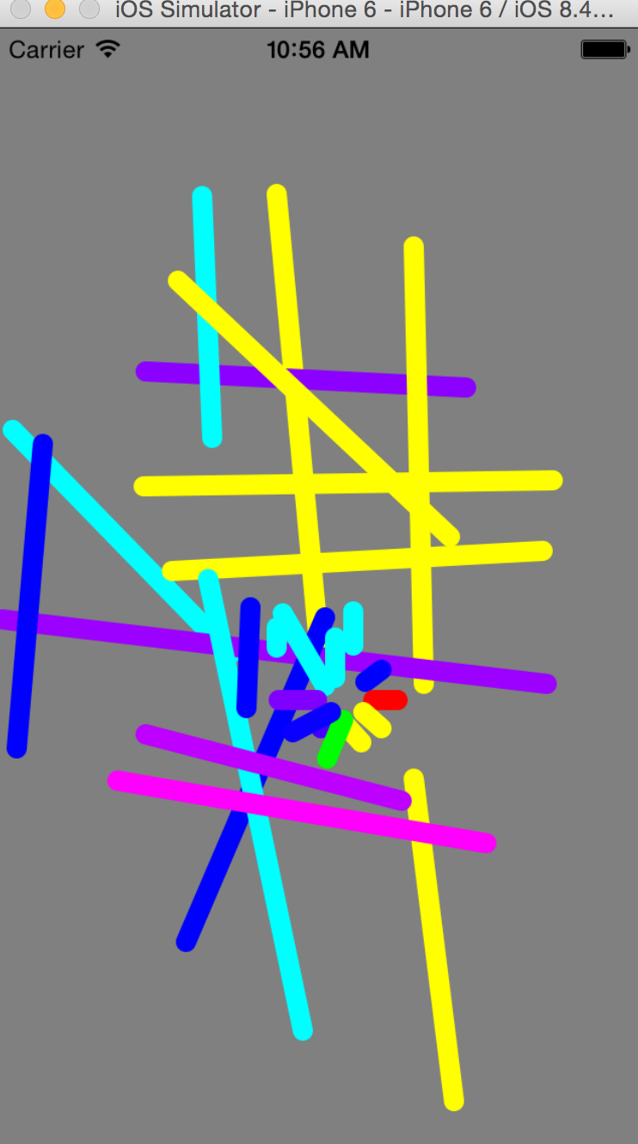

**Silver Challenge chapter 13 page 261**

**Problem:**

There is a bug in the application. If you tap on a line and then start drawing a new one while the menu is visible, you will drag the selected line and draw a new line at the same time. Fix this bug.

**Solution**

This might not be the best solution for this bug, but I just added another conditional statement to the if statement for the moveLine Function:

if (gr.state == UIGestureRecognizerStateChanged && ![[UIMenuController sharedMenuController] isMenuVisible]) {

**Screenshot:**

**Not sure the best way to screenshot this!**

**Selecting the line to delete:**

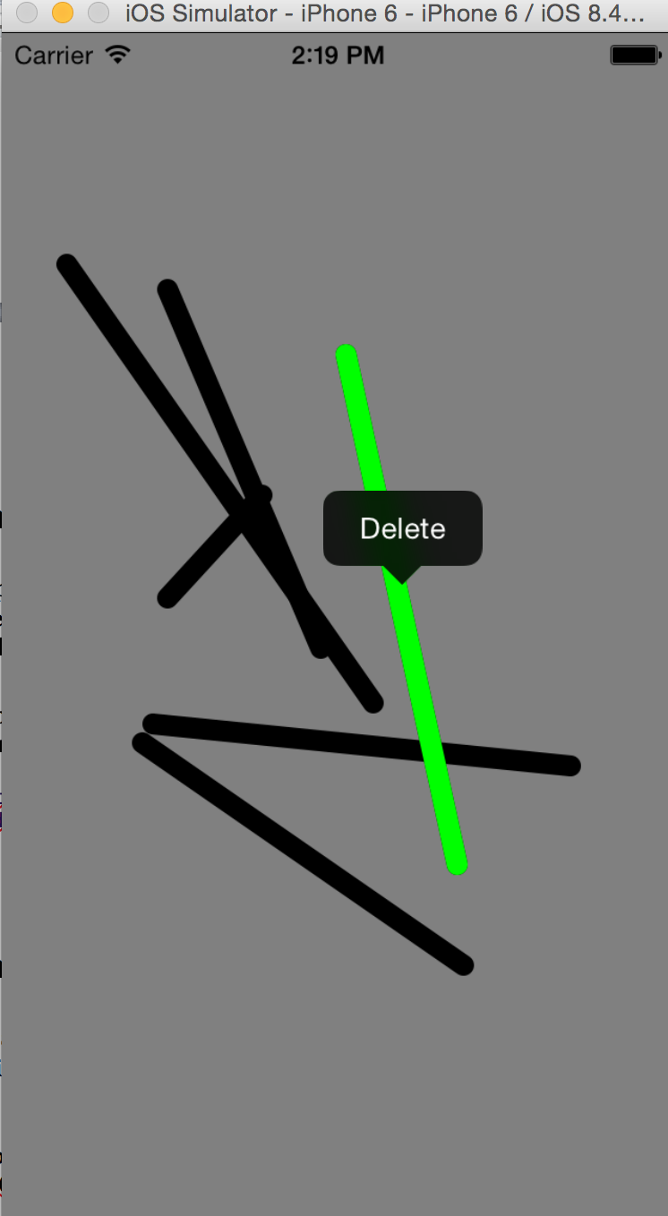

**Adding the next line without movement:**

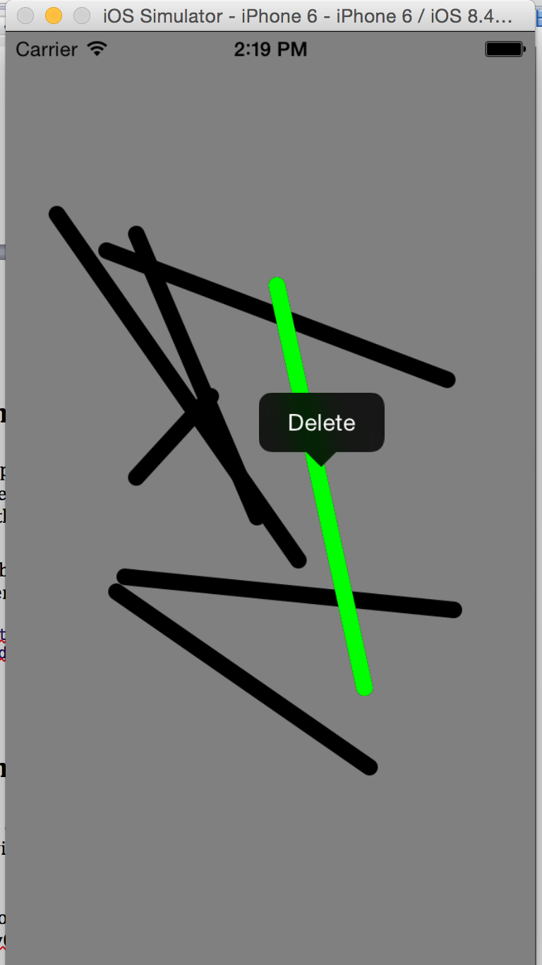

**Silver Challenge chapter 15 page 307**

**Problem:**

Make Quiz a universal application. If you run the universalized app on the iPad simulator without adding any constraints, the interface will look like this:

(The image from the book doesn’t look like my app)

Decide how the interface should look on the iPad and then add constraints in BNRQiuzViewController.xib to ensure that it will appear as you want on any device.

**Solution**

Adjusting the constraints so that the iPad view will look as good as an iPhone view. This process took some time but I adjusted the Show Answer Label and Button to be closer to the Show Question button.

**Screenshot:**

**Starting View:**

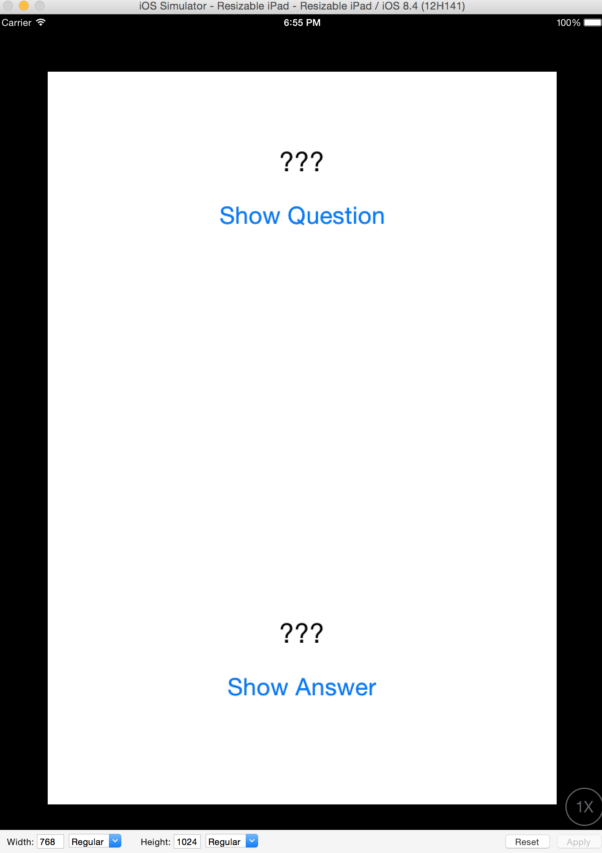

**Adjusted View:**

